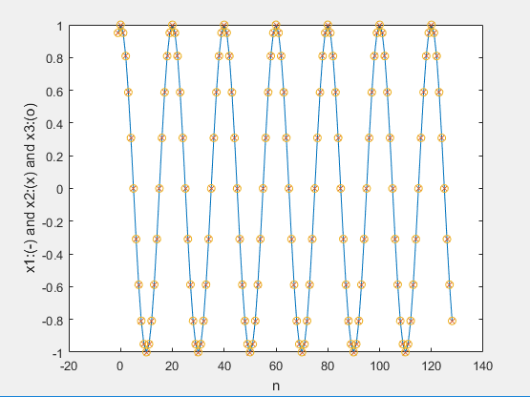
>> cosine
x1:
n = 0:
1

n = 8:
-0.8090

n = 28:
-0.8090

n = 127:
-0.5878

x2:
n = 0:
1

n = 8:
-0.8090

n = 28:
-0.8090

n = 127:
-0.5878

x3:
n = 0:
1
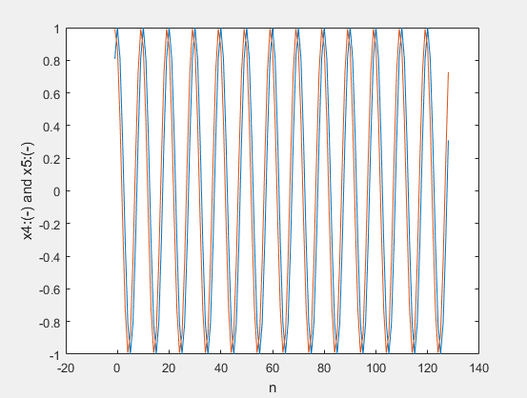
n = 8:
-0.8090

n = 28:
-0.8090

n = 127:
-0.5878

x4:
n = 0:
1

n = 8:
0.3090

n = 28:
0.3090

n = 127:
-0.3090

x5:
n = 0:
0.8776

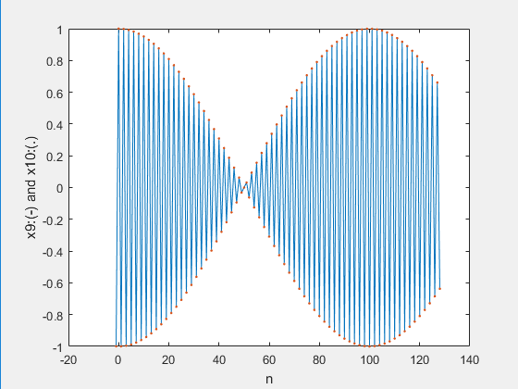
n = 8:
0.7271

n = 28:
0.7271

n = 127:
0.1848

x6:
n = 0:
1

n = 8:
0.3090

n = 28:
0.3090

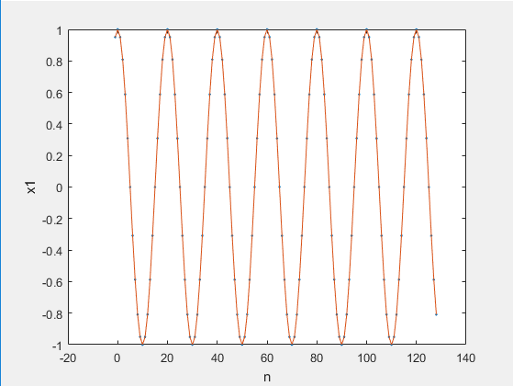
n = 127:
0.9511

x7:
n = 0:
1

n = 8:
0.9686

n = 28:
0.6374

n = 127:
-0.6613
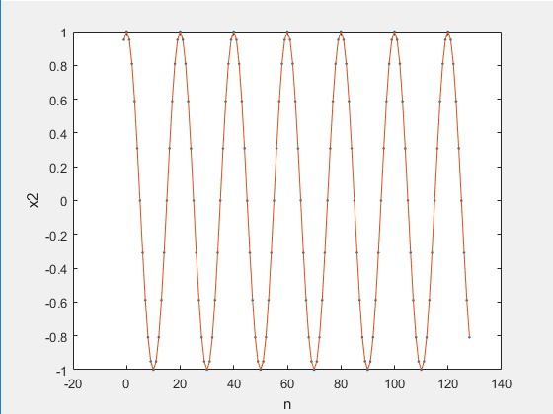
x8:
n = 0:
1

n = 8:
1

n = 28:
1

n = 127:
-1

x9:
n = 0:
1

n = 8:
0.9686

n = 28:
0.6374
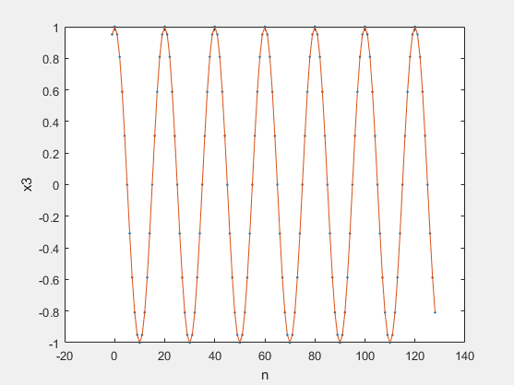
n = 127:
0.6613

x10:
n = 0:
1

n = 8:
0.9686

n = 28:
0.6374

n = 127:
0.6613
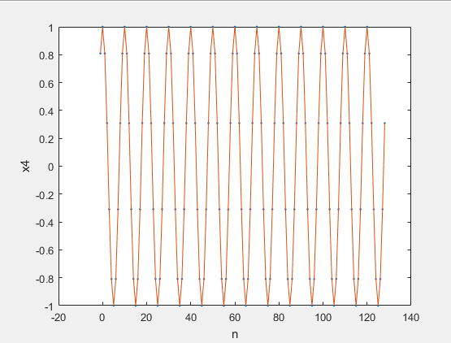
x11:
n = 0:
1

n = 8:
-0.1455

n = 28:
-0.9626

n = 127:
0.2324

x12:
n = 0:
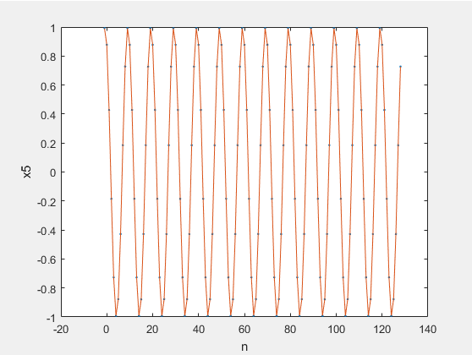
0.8776

n = 8:
0.9833

n = 28:
0.3149

n = 127:
0.1350

fundamental period of x1:
20

fundamental period of x2:
20

fundamental period of x3:
20

fundamental period of x4:
10

fundamental period of x5:
10

fundamental period of x6:
20

fundamental period of x7:
no periods found within 0-127

fundamental period of x8:
2

fundamental period of x9:
no periods found within 0-127

fundamental period of x10:
no periods found within 0-127

fundamental period of x11:
no periods found within 0-127

fundamental period of x12:
no periods found within 0-127
>>

Program code:

n = 0:127;
dense = 0:0.0001:127;

x1 = cos( 0.1 * pi * n);
x2 = cos( 2.1 * pi * n);
x3 = cos( -1.9 * pi * n);
x4 = cos( 0.2 * pi * n);
x5 = cos( 0.2 * pi * n + 0.5);
x6 = cos( 0.3 * pi * n);
x7 = cos( 0.01 * pi * n);
x8 = cos( pi * n);
x9 = cos( 1.01 * pi * n);
x10 = cos( 0.99 * pi * n);
x11 = cos( n);
x12 = cos( 0.7 * n + 0.5);

mydisp( x1);
mydisp( x2);
mydisp( x3);
mydisp( x4);
mydisp( x5);
mydisp( x6);
mydisp( x7);
mydisp( x8);
mydisp( x9);
mydisp( x10);
mydisp( x11);
mydisp( x12);

close all;

figure();
plot(dense, cos( dense), '.',n, x11, '-', n, x12, '-');
xlabel('n');
ylabel('cos( wn + t)');

figure();
plot(n,x1, '-', n,x2, 'x', n,x3, 'o');
xlabel('n');
ylabel('x1:(-) and x2:(x) and x3:(o)');

figure();
plot(n,x4,'-',n,x5,'-');
xlabel('n');
ylabel('x4:(-) and x5:(-)');

figure();
plot(n,x9, '-', n,x10, '.');
xlabel('n');
ylabel('x9:(-) and x10:(.)');

%repetitive parts are ommited.

findPeriod( x1);
findPeriod( x2);
findPeriod( x3);
findPeriod( x4);
findPeriod( x5);
findPeriod( x6);
findPeriod( x7);
findPeriod( x8);
findPeriod( x9);
findPeriod( x10);
findPeriod( x11);
findPeriod( x12);

%this function does not fully work, just for test purposes.
function [period] = findPeriod( mat )
period = 0;
index = 1:128;
periods = find( ( abs(mat(1,1) - (mat(1,index))) < 0.00001));
disp(['fundamental period of ' inputname(1) ':'] );
[x, y] = size(periods);
if( y > 1)
disp(periods(1,2) - periods(1,1));
else
disp(' no periods found within 0-127');
disp(' ');
end
end

function mydisp(b)
disp([inputname(1) ':'] );
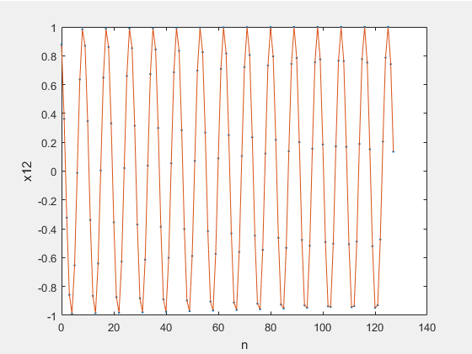
disp('n = 0:');
disp( b(1,0+1));
disp('n = 8:');
disp( b(1,8+1));
disp('n = 28:');
disp( b(1,28+1));
disp('n = 127:');
disp( b(1,127+1));
disp('');
end
